

**VCE Unit 3 Business Management**

**EXAMINATION**

**Practice Exam 2021**

**Question Booklet**

**STUDENT NAME:**

**TEACHER(S):** Ms Emerson-Drake Mr Harris

**TIME ALLOWED: Reading time: 15 minutes**

**Writing time: 90 minutes**

**INSTRUCTIONS**

You are not permitted to use notes, texts or a dictionary.  
You are to answer each question in space provided.  
Do not write in pencil.

**STRUCTURE OF BOOKLET / MARKING SCHEME**

|  |  |  |
| --- | --- | --- |
| Exam Section | Number of questions to be answered | Total marks |
| A  B | 6  5 | 35  20  **Total 55** |

**SECTION A**

**Instructions for Section A**

Answer **all** questions in the spaces provided.

**Question 1** (2 marks)

Define the term ‘public company’.

Provide 2-3 features. Eg. number of owners. Eg. who gets the profits. Eg. liability = 2 marks

* Listed on Australian Securities’ Exchange [ASX]
* Sells shares to an unlimited number of public shareholder owners.
* Limited liability (where shareholder owners are not responsible for any business debts except to the value of their initial share investment)

**Question 2 (9 marks)**

1. Explain onetraining option that would be suitable for a business wanting to multiskill its employees. 2 marks

Choose from ‘on-the-job’ or ‘off-the-job’ training options.

Explore features of what do workers get? Where get it? Who get it from? = 1 mark

Link these features to how ‘multiskill’. Eg. with ‘on-the-job’ training an employee will obtain skills and knowledge from an experienced mentor or two to provide them with a range of workplace skills to help them perform their job effectively. = 1 mark

b.Employee observation is one type of performance management strategy.

Propose a different performance management strategy that you believe would be effective in improving employee performance. Justify your choice. 4 marks

TIP: This Q is NOT asking you to write about a MOTIVATIONAL strategy = NO marks

Outline 1 to 2 features of your chosen strategy – link to why good to increase employee output.

Choose from options such as performance appraisal, management by objectives, self-evaluation.

Propose a performance management strategy = 2 marks

Justify (reasons for choice) = 2 marks

1. Describe a management style and in your answer explain **one** benefit of using this style. 3 marks

Describe management style = 2 marks

Explain one benefit of using this style = 1 mark

Tip: link feature(s) of style to benefit. Eg. 2 way communication = a variety of ideas to improve decision-making.

**Question 3** (4 marks)In the last few years McDonnell’s has seen a steady increase in staff turnover across its five offices in Melbourne. Departing staff complain of a disconnection between management and staff and limited opportunities for them to grow at the business.

Explain two strategies that the business could implement to develop a positive corporate culture.

Identify and explain two clear corporate culture strategies = 2 marks

Suggest how each strategy will develop a positive corporate culture = 2 marks

Examples of corporate culture strategies include:

* Use of heroes as role models for excellent employee behaviour
* Rituals and celebrations eg. celebrate birthdays or successful business events
* Use of symbols
* Change in management styles
* Use of written documentation such as policies

**Question 4** (4 marks)

Read the information in the table below relating to a Victorian business.

Prime Meats Pty Ltd is a manufacturer of various types of processed meats, including ham, salami and sausages. The Operations Manager, Hali, is concerned about the increasing level of wastage and decline in net profit as a result. She has set an objective to reduce wastage from the production process by 90% over the next two years.

|  |  |  |
| --- | --- | --- |
| **Key performance indicator** | **2019** | **2020** |
| level of wastage | ↑ 2% | ↑ 5% |
| net profit | $520 000 | $145 000 |

Explain how the principles of lean management could assist this business with improving its performance. In your response, refer to the data provided.

Outline 1-2 principles of lean management (eg. reduce waste, remove any process that does not add value to the customer needs / final product being produced and delivered, continuous process of improving productivity) = 1 mark

Explain how 1 or 2 examples of the ‘7 types of waste’ method of lean management can improve business performance. Eg. reduce increasing levels of waste = 2 marks

For example, avoid excess inventory so that raw materials for producing the meats are only ordered when needed for production. This reduces disposal of unneeded materials = decreased expenses = increased net profit.

Refer to data in answer =.1 mark

**Question 5** (6 marks)

Some employees reach their targets and pursue excellence while others just show up to work each day and count the hours until the end of their shift.

Compare two theories of motivation. In your response, refer to the statement above.

Refer to statement = 1 mark

1 – 2 similarities = 2 marks

1 to 2 differences = 2 marks

Brief outline of key features of each chosen theory = 1 mark

Tip: choose 2 theories that are easy to compare. Eg. 4 drives and hierarchy of needs. Eg. both have both intrinsic and extrinsic motivators (use examples). 1 theory is progressive whereas other is not (drives can be met in any order - together or individually). 1 has 4 separate drives whereas other has 5 progressive needs. Both have elements that aim to motivate workers. (ie. Sustain output and energy in the long-term)

**Question 6** (10 marks)

Using a business case study from the past four years, illustrate how corporate social responsibility considerations can influence the decisions taken by management in relation to an operations system. Evaluate the potential effects that these decisions may have on **one** stakeholder of the business.

(This Q should be about the UNIT 3 CASE STUDY eg. Cadbury because the topic is OPERATIONS)

Introduction - Outline chosen case study introducing outline of CSR decisions that this business has made = 1 mark

Choose 2 or 3 CSR decisions to explain. Use specific examples = 6 marks.

**Evaluate** (+ and – plus final opinion) about the impact that one or more of these decisions has had on one stakeholder. NB. Be specific about the impact – has it been POSITIVE or NEGATIVE? = 3 marks.

Eg. Cadbury has made a number of CSR (expand) decisions regarding its operations (production of goods eg. chocolate bars and chocolate boxes). It has used elements of its operations (IPO) to improve its customer perception of the business and increase its number of sales.

Eg. Inputs – Cocoa Life program with sourcing of cocoa beans in Ghana = ^ wages and conditions for workers in this developing country. Plus provides ongoing employment = ^ incomes and living standards due to sustainable farming practices. = + positive view of this by customers = + impact leading to ^ sales.

Eg. Processes – use of wind power in steam processes to reduce CO2 pollution and decrease global warming impact = + customer view = ^ sales. [OR collection of steam to reuse as energy to reduce energy bills = + impact on manager as reduces expenses to ^ profit]

Eg. outputs – use of biodegradable corn starch plastic trays in chocolate boxes = reduced landfill waste = + customer view = ^ sales OR + view by shareholders = increased investment in business (can raise funds for expansion eg. new locations or new product ranges)

A weakness of Cocoa Life program is that these cocoa beans have a higher cost = ^ input costs = reduced profit = negative impact on manager and / or ^ retail prices = negative impact on customer = possible reduction in total number of sales.

BUT, overall, these CSR decisions are a benefit for the business because many customers will value this clear concern for business activities having a positive impact on both the community and environment = likely ^ total sales.

**SECTION B**

**Instructions for Section B**

Use the case study provided to answer the questions in this section. Answers must apply to the case study. Answer **all** questions in the spaces provided.

Compucinch Pty Ltd is an IT consultancy business established 15 years ago by its CEO, David Myles. The company specialises in the provision of expert advice, assistance and support to clients making IT software and hardware purchases. Step-by-step instructions and advice are provided to clients while they are making these purchases.

Compucinch has grown to employ 30 full-time employees since the establishment of the business. All of Compucinch’s employees are currently working under award pay and conditions.

Digipurchase Pty Ltd is a competitor of Compucinch and offers a similar product range. Over the past six months, three of Compucinch’s employees have resigned to take up positions with Digipurchase. Exit interviews have shown that the departing employees have been attracted by the more generous pay and conditions offered in the Digipurchase enterprise agreement.

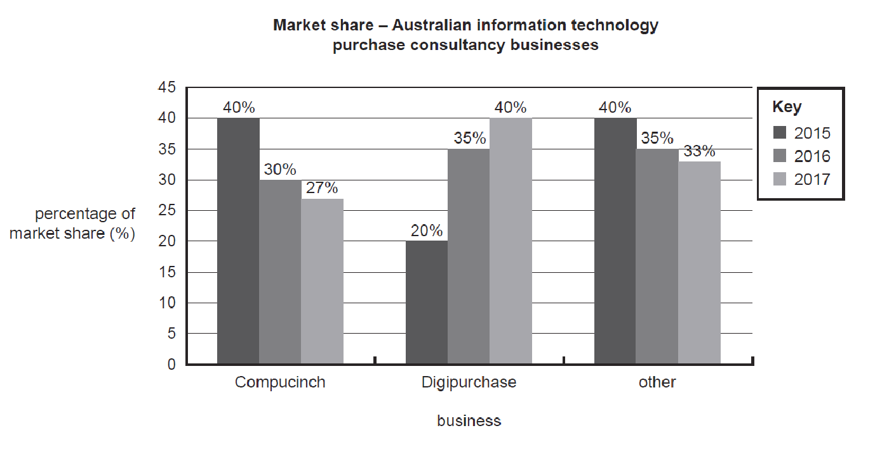

**Question 1** (2 marks)

Outline an entitlement issue Compucinch would need to consider when managing resigning employees.

Tip: the Q asked for an example related to a ‘resigning’ employee. Thus the legal obligation of ‘redundancy payments’ is NOT relevant – as resignation is a VOLUNTARY type of termination.

Remember, entitlements are LEGAL OBLIGATIONS that a workplace must pay employees when they end their employment contract.

NB. Unused sick leave is NOT paid out when leave a job.

Options include payment for accrued (not taken) annual leave OR accured long service leave.

The Q also asks for ‘an’ which means ONE example. This one example must be explained fully. For example, payment for any of the unused Australian legal obligation for one month of paid annual leave per year.

**Question 2** (2 marks)

As the CEO of Compucinch, David will need to possess and apply many management skills.

Explain how David might utilise planning and interpersonal skills in order to manage Compucinch effectively.

Tip: many students forgot that there were TWO management skills listed.

Aim to avoid ‘circular’ language – and link theory to case study examples.

Explanation of how the business could use each skill = 1 mark each = 2 marks total.

For example, planning is formal decision-making that is future orientated. Compucinch could make a decision to train staff in software product knowledge in the next 1 to 2 years to increase % market share.

For example, interpersonal skills are how managers communicate and interact with staff eg. communication with staff about the need for product knowledge training so that they can sell IT software products with confidence.

**Question 3** (4 marks)

Manufacturing and service businesses are identified by a number of characteristics. With reference to Compucinch and a manufacturing business of your choice, distinguish between the characteristics of the output elements of each type of business.

Distinguish two characteristics = 2 marks [include a linking word such as ‘whereas’]

Provide 2 examples = 2 marks

Tip: This Q restricts the characteristics to examples of operational outputs.

It is also necessary to use specific examples of a manufacturing business (eg. Cadbury) to contrast with Compucinch and its software services. NB. The Q asks for ‘distinguish’ so only differences are required.

For example, It services are intangible where they cannot be touched whereas Cadbury chocolate bars are tangible where they can be touched.

For example, the outputs of IT services delivered cannot be stored as inventory whereas boxes of Cadbury chocolate bars can be stored after being produced.

For example, the customer would be present during the delivery of the IT service advice at Compucinch whereas the customer would not be present during the production of Cadbury chocolate bars in the factory.

**Question 4** (8 marks)

1. Define the key performance indicator ‘percentage of market share’. 1 mark

Tip: use key terms and avoid circular language.

Use key features such as number of sales a business has compared to competitors in the relevant ‘industry’. An example of this from a VCAA chocolate case study Q is shown below. Remember that a ‘high-scoring answer’ is not always perfect – so remove circular language from this sample answer!

1. Interpret the market share data and propose how Compucinch could use one motivational strategy to increase employee job satisfaction in the short or long-term and reduce staff turnover. 3 marks

Interpret market share data – by outlining how Compucinch is performing compared to at least 1 competitor in the IT consultancy advice industry. = 1 mark

How use one motivational strategy = 1 mark (include how short or long term motivation)

How reduce staff turnover = 1 mark

Examples of motivational strategies include:

* Investment in training = provide skills and knowledge in IT services and products = long-term motivation and career satisfaction = staff wish to remain at the business.
* Career advancement = promote to position of responsibility = long-term motivation and job satisfaction = wish to remain at business.
* Performance-related pay – offer bonus for good sales performance = short-term motivation = limited impact on reducing staff turnover.

1. Discuss how Compucinch could use Total Quality Management to improve its market share. 4 marks

Discuss = pros and cons = 3-4 points

Must include at least one pro and one con.

Tip: link features of this quality strategy to how attract customers from competitors in IT service advice industry. DO NOT just state descriptions of features – modify these features as a ‘positive’ element.

For example:

Continuous process involving all employees and managers to improve standard of IT services in the industry.

Proactive process of improving standard of service delivery by identifying possible problems with IT service delivery and eliminating these prior to customer delivery.

BUT, time-consuming process of training all staff in how to improve standard of IT advice services.

Also, costly to train staff in all aspects of IT service delivery.

**Question 5** (4 marks)

Justify the benefits of choosing an agreement instead of an award for Compucinch.

Justify 2-3 reasons for choosing an agreement = 3 marks

Link to why better than award = 1 mark

Tip: ‘justify’ means reasons for choosing NOT pros and cons.

Why is an agreement good?

For example, it pays wages and conditions higher than an award

In your answer, WHY BETTER than an award. For example, it is better than an award because an award only provides wages and conditions of employment that link to the minimum standards provided in an industry of workers. Eg. 10 National Employment Standards.

Using an award is likely to increase productivity – an increase in wages and conditions can be directly linked to productivity (output) improvements – thus helping business to improve performance compared to competitors in IT services industry.

**END OF EXAMINATION**

**Extra space for writing**

|  |
| --- |
|  |
|  |
|  |
|  |
|  |
|  |
|  |
|  |
|  |
|  |
|  |
|  |
|  |
|  |
|  |
|  |
|  |
|  |
|  |
|  |
|  |
|  |
|  |
|  |
|  |
|  |
|  |
|  |
|  |
|  |

|  |
| --- |
|  |
|  |
|  |
|  |
|  |
|  |
|  |
|  |
|  |
|  |
|  |
|  |
|  |
|  |
|  |
|  |
|  |